A New MOU Paves the Way for the Management of HIV/TB in Homa Bay County

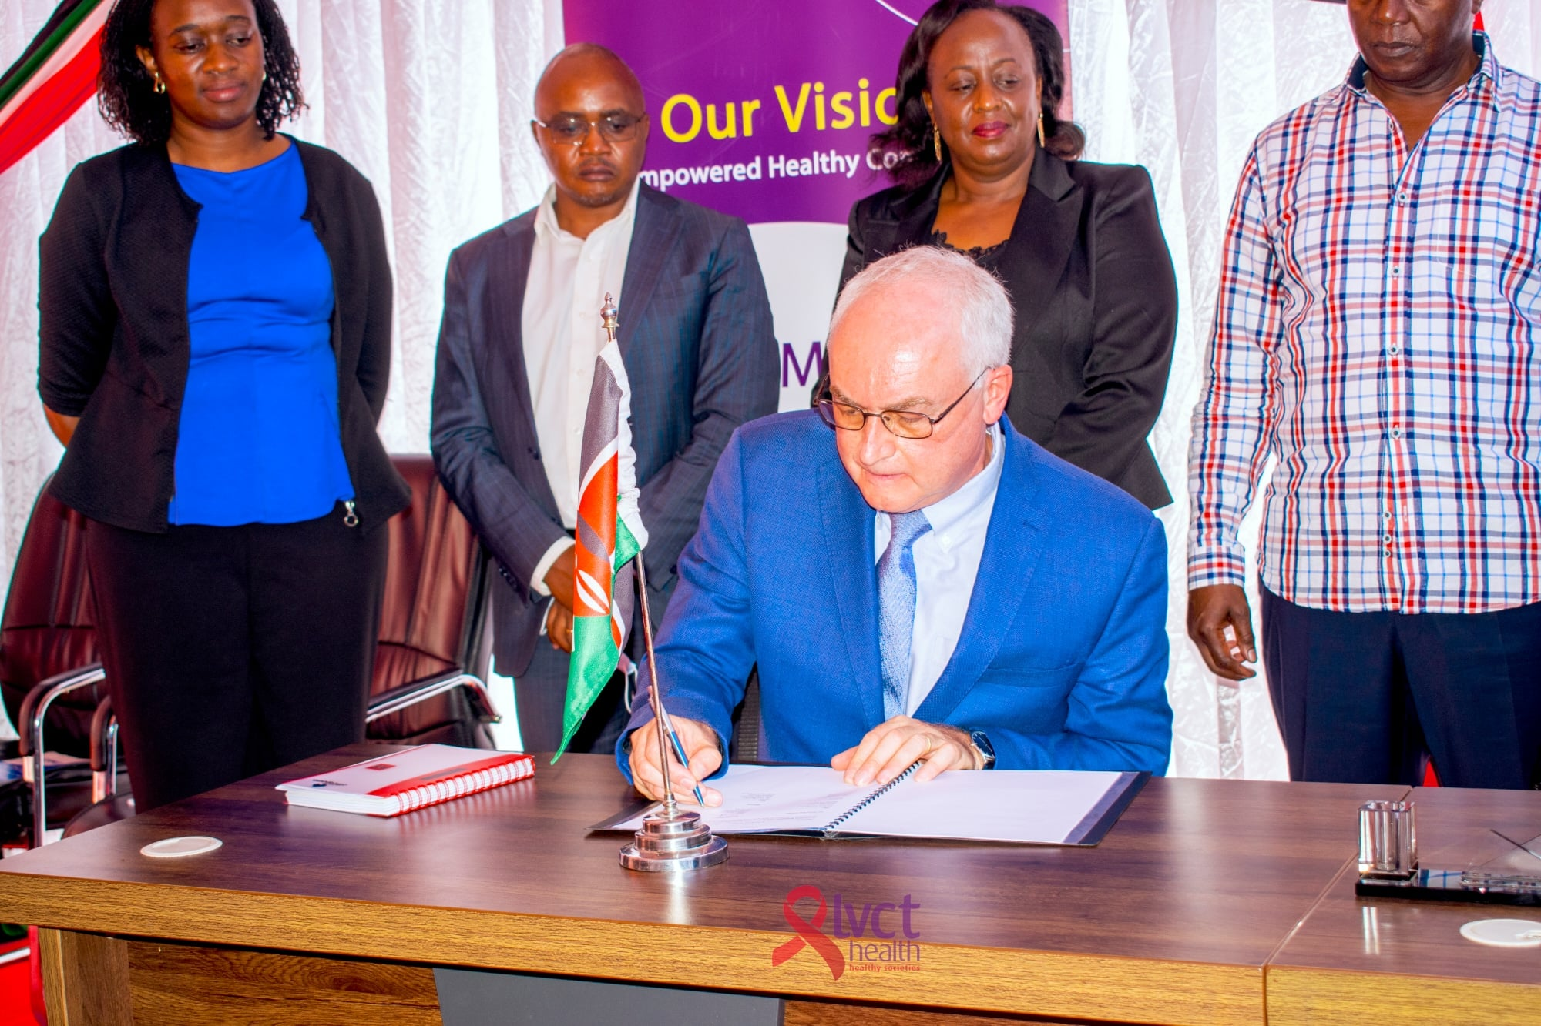

The Centers for Disease Control and Prevention (CDC) in Kenya and Homa Bay County government signed a Memorandum of Understanding (MOU) as part of the government-to-government funding mechanism to ensure continuity of support in the management of HIV/AIDS and Tuberculosis (TB) in the County.
Speaking during the signing ceremony held at the Governor’s office, Dr. Marc Bulterys, the Country Director, CDC-Kenya, said the MOU is a significant step in creating self-reliant communities.
He acknowledged the efforts of LVCT Health and other non-state actor organizations working in the County in addressing HIV/AIDS and other health-related challenges such as TB and Malaria.
LVCT Health is implementing Vukisha95, a five-year, CDC-funded program to ensure sustainable implementation of comprehensive, high-quality HIV prevention, care, and treatment interventions in Homa Bay and Kisii Counties.
In its five-year implementation period, LVCT Vukisha95 will focus on reaching men, pregnant women, children, adolescent girls and young women, and other key populations, including health care providers across the selected service delivery sites of the two target counties.
H.E. Cyprian Awiti, the Homabay County Governor, said that the County has relied heavily on development partners to fund the various health programs.
“For a decade now, CDC-Kenya has been our prime partner, financing numerous partners in the management and treatment of HIV/AIDS and TB, including building the capacity of our health care workers to deliver crucial health services to the community,” said Awiti.
The MOU makes Homabay the first County in Kenya to receive the new support model that seeks to foster self-reliant communities and end reliance on foreign assistance.
LVCT Health Executive Director Dr. Lilian Otiso stated that LVCT Health will remain at the forefront in reducing new HIV infections by increasing equitable access to quality health services through innovative, integrated, comprehensive, and high-impact services and programs that can be delivered at scale.
She acknowledged the continued support from CDC Kenya in ensuring people living with HIV/AIDS have access to quality treatment and management services to live a full and productive, healthy life.
The MOU will see the entities formulate a structured roadmap to ensure smooth transition and absorption of partner-supported staff by the county government, including the supported health initiatives.

