LVCT Health, Nyeri County Sets the Ground for New Partnership for Health Support
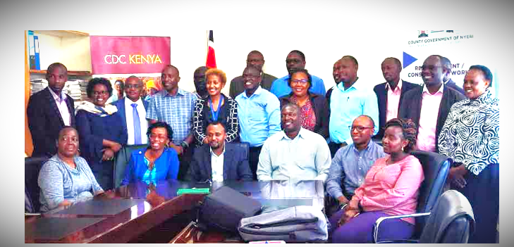

Ibrahim Adam, the County Health Chief Officer, seated, third left) with lead partners in health from the Center for Health Solutions'Tegemeza Plus, LVCT Health's Dhibiti, and Elizabeth Glasser Pediatric AIDs Foundation (EGPAF).

The Department of Health Services, Nyeri County hosted Center for Health Solutions (CHS) Tegemeza Plus, LVCT Health and Elizabeth Glaser Pediatric Aids Foundation (EGPAF) for a partner transition meeting following the close out of the Tegemeza Plus project.

LVCT Health takes over from CHS to implement the new CDC-funded Dhibiti project that seeks to support the implementation of sustainable, comprehensive, high-quality HIV prevention and treatment programs in four counties of central Kenya, namely Kiambu, Murang'a, Nyeri and Kirinyaga.

In 2019, Nyeri County was among the 13 Counties that applied for a PEPFAR funding opportunity and was awarded the grant in December 2020. This funding model led to a transition of the program from CHS-Tegemeza to the Department of Health Services in May 2021.

During the meeting, Ibrahim Adam, the County Health Chief Officer, said that with new partners on board, Tetu Sub County would be added as part of an expanded scope to reach more people in need of health services.

He noted that the County is committed to improving health outcomes and will work closely with various partners to complement efforts to deliver quality and sustainable health services.
LVCT Health's Dhibiti, in Partnership with EGPAF, will support six sub-counties in Nyeri County.

Through the Project, LVCT Health working closely with target counties hopes to contribute to the ambitious 95-95-95 targets to help control the HIV/AIDS epidemic.

Dhibiti (Kiswahili word for taking control of the HIV epidemic by the county governments) Project is a five-year project funded by the President's Emergency Plan for AIDS Relief (PEPFAR) through the Centres for Disease Control and Prevention (CDC in Kenya).

Source: Photograph captured by Catherine Muthoni.

